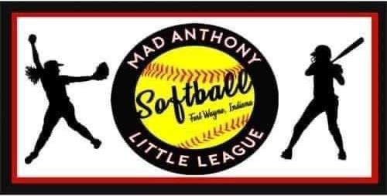
Be Part of Our Legacy
We are Mad Anthony Little League Softball. Our organization was formed by merging three of Fort Wayne’s Softball Programs into one for a common goal, to bring a dedicated Softball Program to our community. Elmhurst, Foster Park, and Hamilton Park Little Leagues are all well known in Fort Wayne for their baseball programs. Although each park had its own Softball League, our volunteers, our parents, and our players felt it was time to break free and plant our own roots in the community. Our newly elected board is excited and dedicated to working with our girls and our community, and helping our girls to reach their best potential.
We are a softball community that covers most of Southern Allen County and some of Northern Wells County as well. We have a diverse group of girls from urban to rural areas that need our League, its volunteers and coaches, and as much community support possible. Together, with your donations, we will be able to make sure that our league and fields are safe, prepared, and equipped with all of the things that these girls need to be successful not only at playing softball, but making new friends, finding a mentor, building confidence, and developing sportsmanship.
By the age of 14, girls drop out of sports twice as often as boys. Factors such as, lack of access, transportation issues, costs, and lack of positive role models can all contribute to the reasons why girls drop out of sports in their adolescent years. We strive to break down all these barriers, provide access to a quality sports program, and ensure that positive role models inspire our young girls.
Mad Anthony Little League is committed to serving all in our community, including those less fortunate. We want to ensure that any girl who wants to play will be able to play.
Your tax-deductible donation to our league, will allow us to reach all of our goals. We have many repairs that need done at our diamonds such as upgrading our score boards, bases, pitching mounds, dugouts and concession stand. Donations will also help with Umpire fees, equipment upgrades, providing uniforms to players, lawn care, and to help those who may not be able to afford to play feel welcome and a part of our Mad Anthony Community.
Your Home run Sponsorship Support will include: $600
- Company Name or Logo Printed on Uniform Chest
- Company Banner Hung at 1 of our 2 Diamonds
- Company Name or Logo Featured on our Website and Facebook
- Becoming an IMPORTANT part of the Mad Anthony Little League Family
- Helping Girls in our community
Park Sponsorship Support will include: $375
- Company Banner hung at one of our 2 Diamonds
- Company Name or Logo featured on our Facebook and Website
- Becoming an IMPORTANT part of the Mad Anthony Little League Family
- Helping Girls in our Community
Your Friend of Mad Anthony will include: $150
- Will Sponsor a Young Lady who otherwise might not get a chance to play!
Please contact us at MadAnthonyLLSoftball@gmail.com to arrange pick up or delivery of donated items.
Mail donations to: 405 Greenwood Trail, Ossian IN 46777

